Simple momentum and mean reversion ideas from Ernest Chan
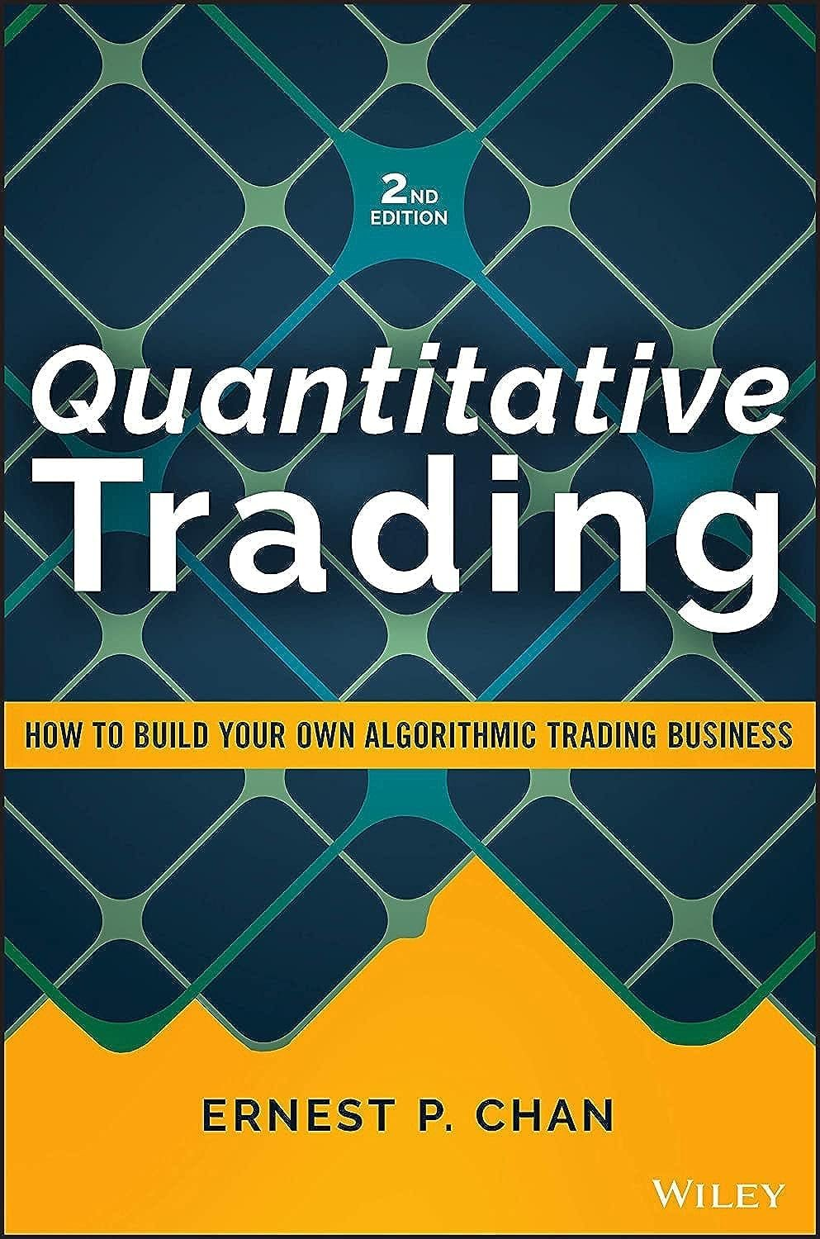

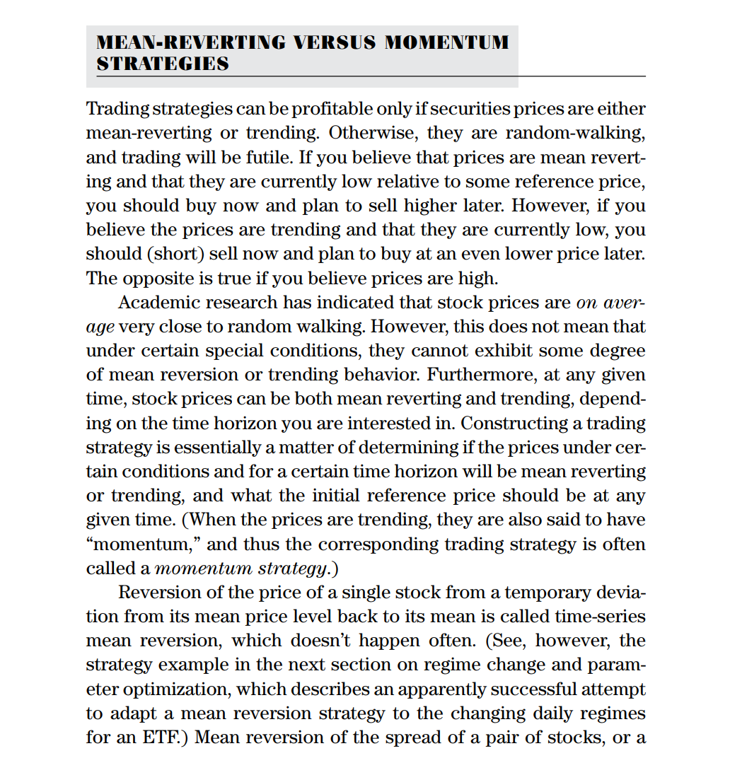
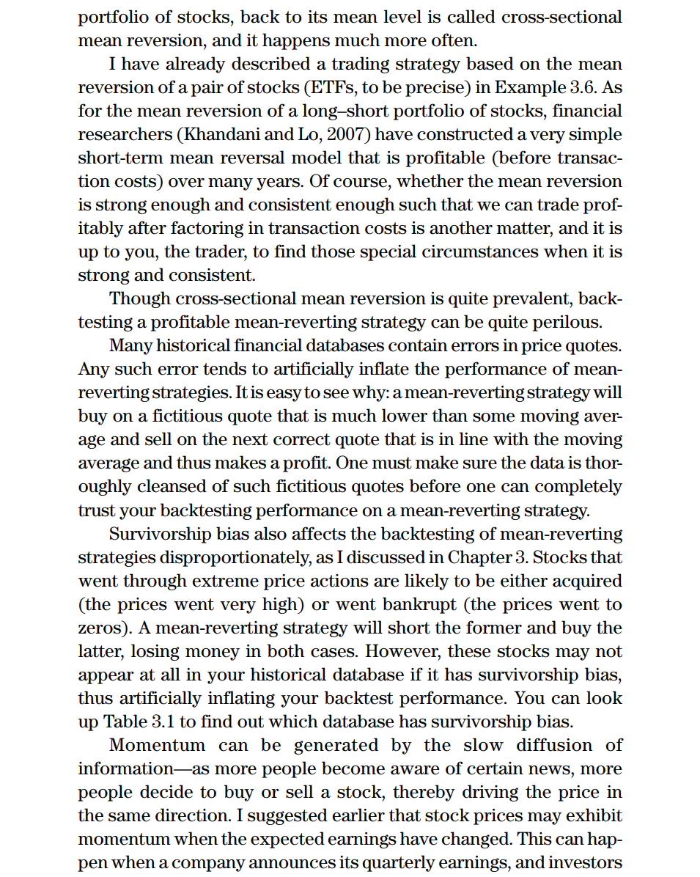
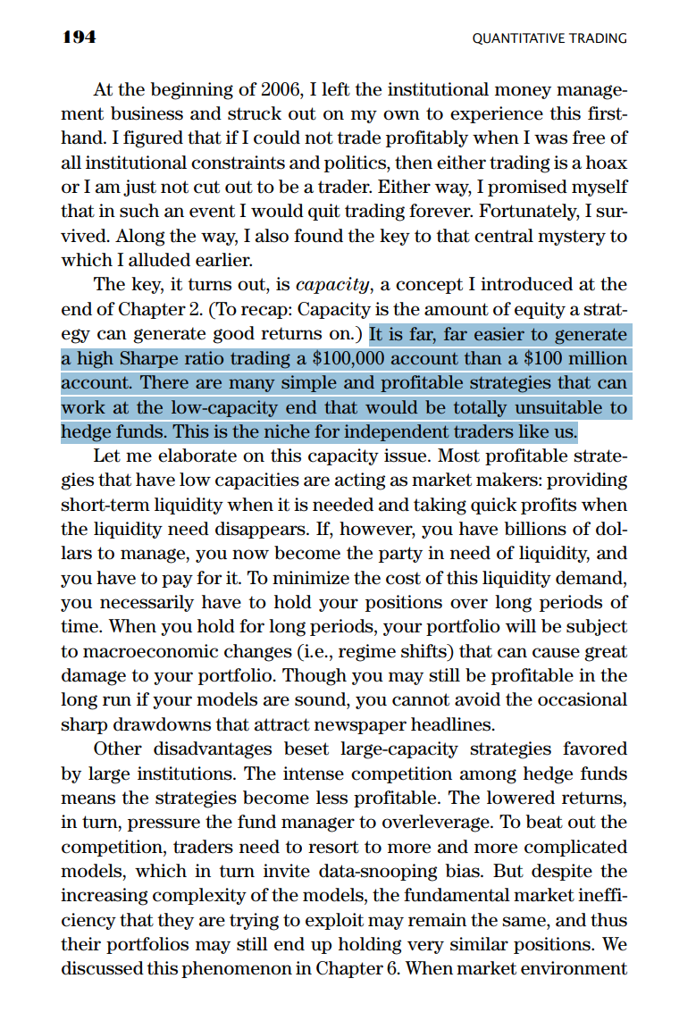
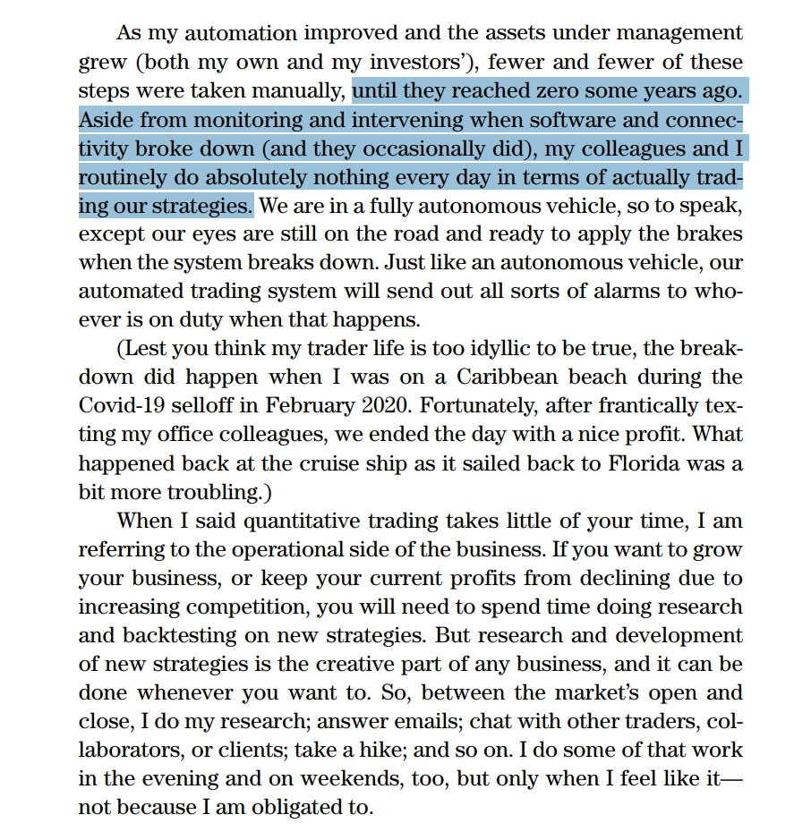

https://x.com/GoshawkTrades/status/1937622320451059935?s=19

https://x.com/GoshawkTrades/status/1937622446498287836?s=09

